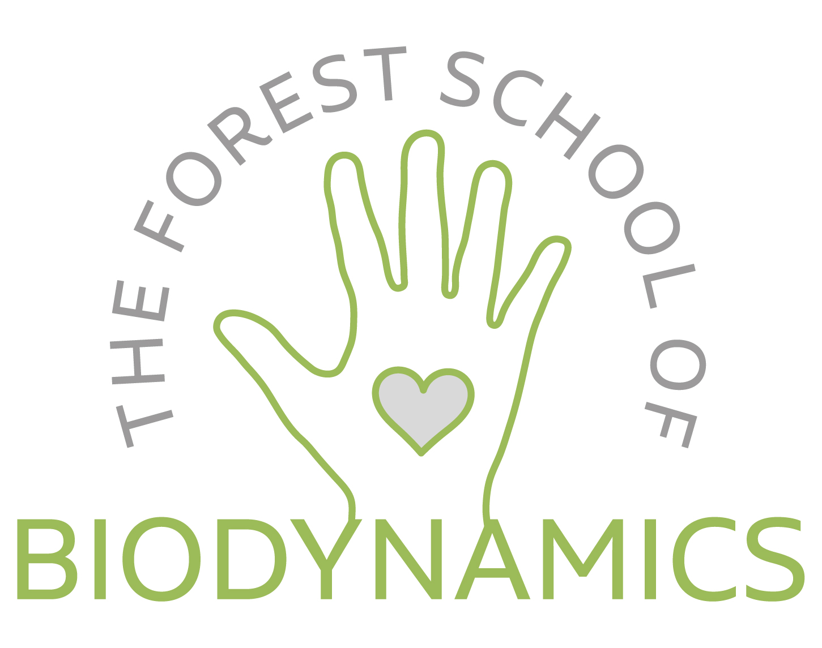

Application for (please enter name and dates of the course here)

Name (as you would like it to appear on your certificate):

Address:

Telephone:

Email address:

Professional Qualifications: (e.g. Association registration etc.)

Description of Professional Practice: (what is the nature of your practice?
How many clients do you see per week, how many years in practice?)

Previous Craniosacral Therapy Training (Please specify if you have attended previous biodynamic courses) Including length of course (days)

What brings you to this training?

Any health conditions or allergies we should be aware of?

Any specific dietary needs?

Any other relevant information:

Purpose of the Training

- To engage in a circle of reciprocal healing with the natural world
- To provide an in-depth understanding and appreciation of the unfoldment of the Breath of Life and its ordering and healing functions in the human system.
- To foster the deepening of practitioner presence, awareness of and orientation to the biodynamic fields.
- To deepen awareness and skilled negotiation of the relational field and relational approaches to healing, including relational touch and mindfulness based verbal skills.
- To be able to apply these principles clinically.

Application Requirements

This non-residential course is open to CST graduates of any school. It will benefit those who wish to deepen their understanding of the Biodynamic paradigm, to ground and upskill their practice, and to benefit from being in a beautiful natural environment, taking time out in retreat from their daily life.
Places in the course are limited to 8.
Please make your deposit payment of £100 to secure your place:
Forest School of Biodynamics A/C 31265477 S/C 23 69 72

